Project Design Phase-II
Data Flow Diagram & User Stories

Date | 25 June 2026
Team ID
Project Name | An employee requests installation of licensed software through the Service Catalog
Maximum Marks | 4 Marks

Data Flow Diagrams:
A Data Flow Diagram (DFD) illustrates how data flows through the Software Installation Request System in ServiceNow. It shows how an employee submits a request through the Service Catalog, how it is processed, approved, converted into fulfillment tasks, and stored in tables such as sc_request, sc_req_item, and sc_task. The DFD provides a clear view of the system workflow and data movement, ensuring an efficient and traceable request process.

Example: (Simplified)
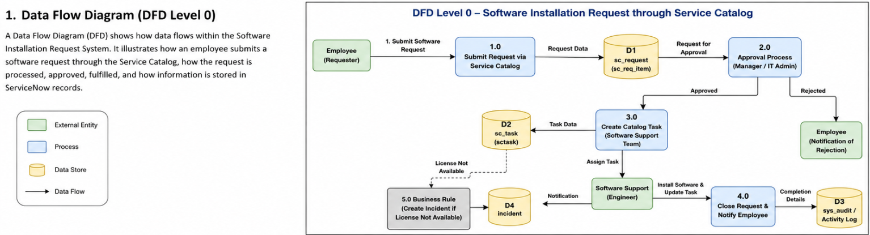

User Stories
Use the below template to list all the user stories for the product.
User Type | Functional Requirement (Epic) | User Story Number | User Story / Task | Acceptance criteria | Priority | Release
Employee | Software Request | USN-1 | As an employee, I can submit a software installation request through the Service Catalog. | Request is successfully created with a Request Number. | High | Sprint-1
Employee | Software Details | USN-2 | As an employee, I can enter Software Name, Version, Business Justification and Urgency. | All mandatory fields are validated before submission. | High | Sprint-1
Manager | Approval | USN-3 | As a manager, I can approve or reject software requests. | Request status changes after approval or rejection. | High | Sprint-1
Software Support Team | Task Management | USN-4 | As a software support engineer, I can receive catalog tasks automatically after approval. | Catalog Task is generated and assigned automatically. | High | Sprint-1
Software Support Team | Installation | USN-5 | As a software support engineer, I can update installation progress. | Task state changes to Work in Progress and Closed Complete. | Medium | Sprint-2
Employee | Status Tracking | USN-6 | As an employee, I can track my software request status. | Employee can view REQ, RITM and Task status. | Medium | Sprint-2

